# DIY Inductor Project

## Introduction

The goal of this project is to gain a solid understanding of how inductors are constructed and how their inductance is affected by its various physical properties. Additionally, the time varying nature of inductors’ “charge” and “discharge” times is explored.

## Discussion Overview

### Inductor Construction

Inductors are usually constructed by wounding an insulated conductor such as a wire into a coil. The core of an inductor can be empty (air) or a ferrite material. The inductance of an inductor is directly proportional to the surface area of the coil’s cross section *(A)*, the number of windings *(N)*, the permeability (a measure of how well the electron dipoles of core can align themselves) of the core *(r)* and the Nagaoka Coefficient *(K)*. The inductance, on the other hand, is inversely proportional to the length of the coil *(l)*.

$$L=μ_{r}KN^{2}\frac{A}{l}$$

The Nagaoka Coefficient is usually looked up from a table and is dependent on the ratio of the length of the coil to its diameter. However, for coils where the length is sufficiently larger than its diameter, this coefficient is set to 1.

The relative permeability *r* is the ratio of the permeability of the ferrite material used as the core to the permeability of air.

$μ_{r}=\frac{μ}{μ_{0}}$, where $μ_{0}=4π×{10}^{-7}$.

In the first part of this project, we will attempt to build an inductor out of a length of magnet wire and cardboard tube. We will, then, estimate the inductance of our inductor using the equation above. In the second part, we will try to determine the “actual” inductance of our inductor by measuring the “charge/discharge” time.

### Charge/Discharge Time of an RL Circuit

An inductor is a passive device for storing energy in the form of a magnetic field. When an electric source like a battery is connected to an inductor, the battery places a voltage potential across the inductor. The change in current due to the presence of this voltage potential creates a magnetic field around the inductor which resists the instantaneous buildup of current. As the current slowly builds up to its max, the magnetic field (or flux) around the inductor reaches its full strength and the voltage across the inductor drops to zero.

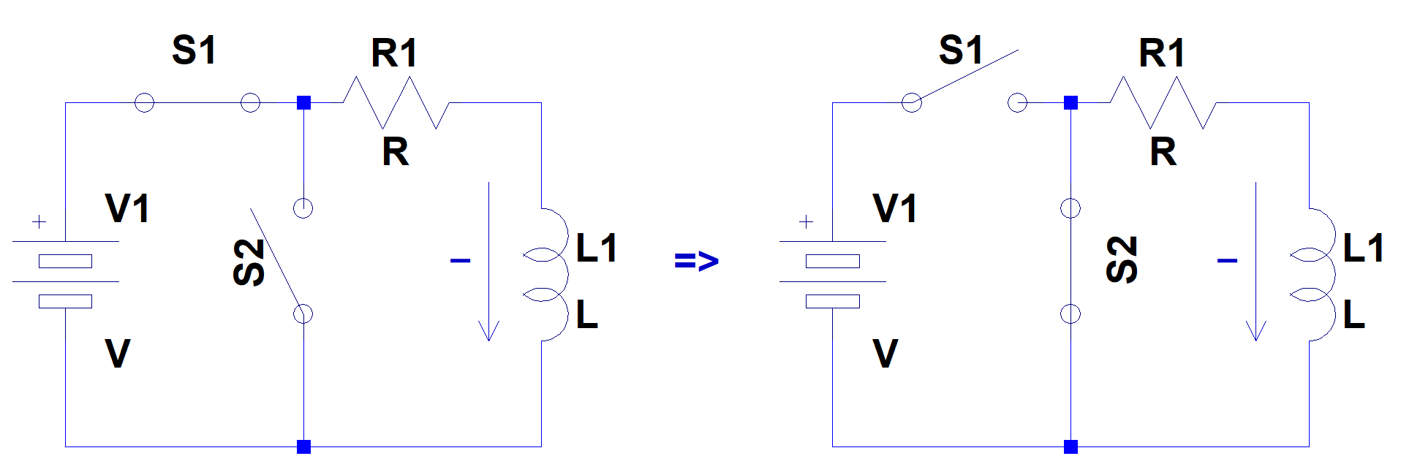

At the moment a battery is attached to an inductor, the voltage across the inductor is at its largest (equal to the voltage source) and the current going through the circuit is at its minimum (zero). Therefore, an inductor acts as an open (switch) when it encounters an abrupt change in voltage.

As the current builds up to its max, the voltage across the inductor drops to its lowest (zero). Therefore, an inductor acts as a short (closed switch) when the circuit reaches its steady state.

If, once the inductor has fully charged, the battery is disconnected and the inductor is connected to a load (resistor), the magnetic field around the inductor starts to collapse. This collapse in the magnetic field induces a voltage across the inductor which keeps the current flowing. In other words, an inductor resists an abrupt change in current flow and tries to keep it flowing. However, as the magnetic collapses to zero, the current slowly comes to a stop (zero) and the voltage potential across the inductor drops to zero as well.

The time profile for charge/discharge of an inductor through a resistor is shown in the diagram below. The chart displays the charge time of an inductor as a function of multiples of *L/R* time constants.

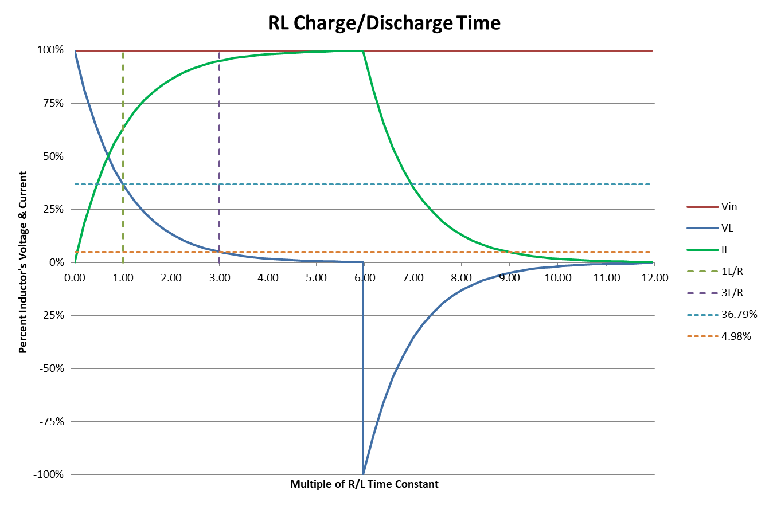

When charging, the voltage across an inductor drops from its max by ~63% (to ~37% of its max) after a time *t63% = 1L/R*, and it drops by ~95% (to ~5% of tis max) after a time *t95% = 3L/R*. As seen from the chart, during this same time, the current through the inductor builds up to ~63% of its max in *t63% = 1L/R* time and ~95% of its max in *t95% = 3L/R* time.

The discharge time follows a similar profile except that at the moment the voltage source is disconnected, the voltage across an inductor changes directions (sign) to keep the current flowing. As the magnetic field around the inductor collapses, the voltage across it again drops to ~63% of its max in a time *t63% = 1L/R*, and ~95% of its max in a time *t95% = 3L/R*. The current drop, during this time, follows the same profile.

## Procedure

Part 1: Building an Inductor

Material needed:

* Cardboard tube
* Scotch or electric tape
* Gauge 22 magnet wire

Steps:

* Markings:
  + Take one cardboard tube and draw a straight line along its length. This line will act as a marker for counting the number of wire loops as you wind the wire around the tube.  
      
    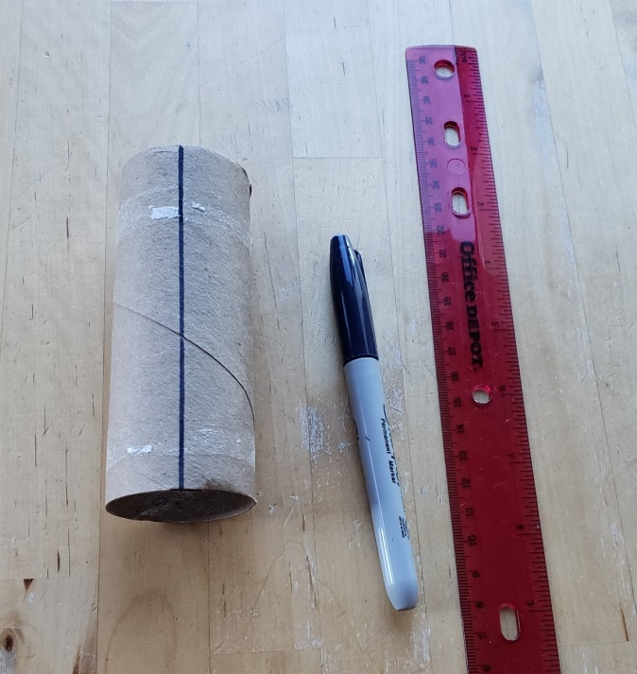
  + Measure the radius of the cardboard tube and record it below $$r=__________________m$$
  + Determine the cross section area of the tube and record it below. (This will be the cross section area of your coil.) $$A=2πr=__________________m^{2}$$
  + Using a piece of an electric tape or Scotch tape, tape one loop of gauge 22 magnetic wire around the tube. Make sure ~2-3” of wire extends out; this will be one lead of the inductor.  
      
    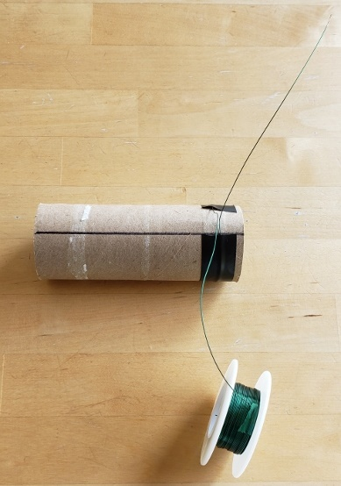
  + Wind 80 loops of wire around the tube making sure each loop is adjacent to the previous turn. There should be no gap between each loop of your coil.
  + Use electric or Scotch tape to tape the last loop onto the tube. Again, make sure ~2-3” of wire extends out at the end; this will be the second lead of your inductor.  
      
    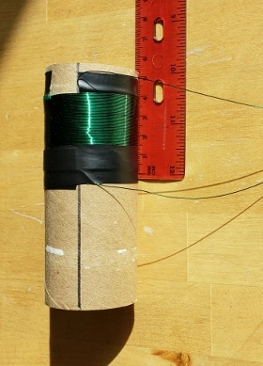
  + Measure the length of the coil and record it below. (For example, in the picture below, the length of the coil is ~39mm or ~0.039m.)  
      
    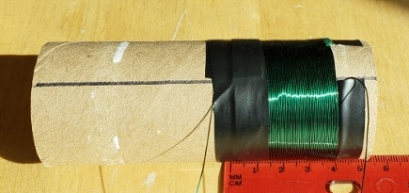 $$l=__________________m$$
* Calculating the inductance:
  + Using the values recorded above and the permeability of air $μ_{0}=4π×{10}^{-7}$ and *K* = 1, determine the inductance of your inductor $$L=μ_{r}KN^{2}\frac{A}{l}=____________________μH$$

Part 2: Measuring the Inductance

* Build the following circuit using your DIY inductor  
    
  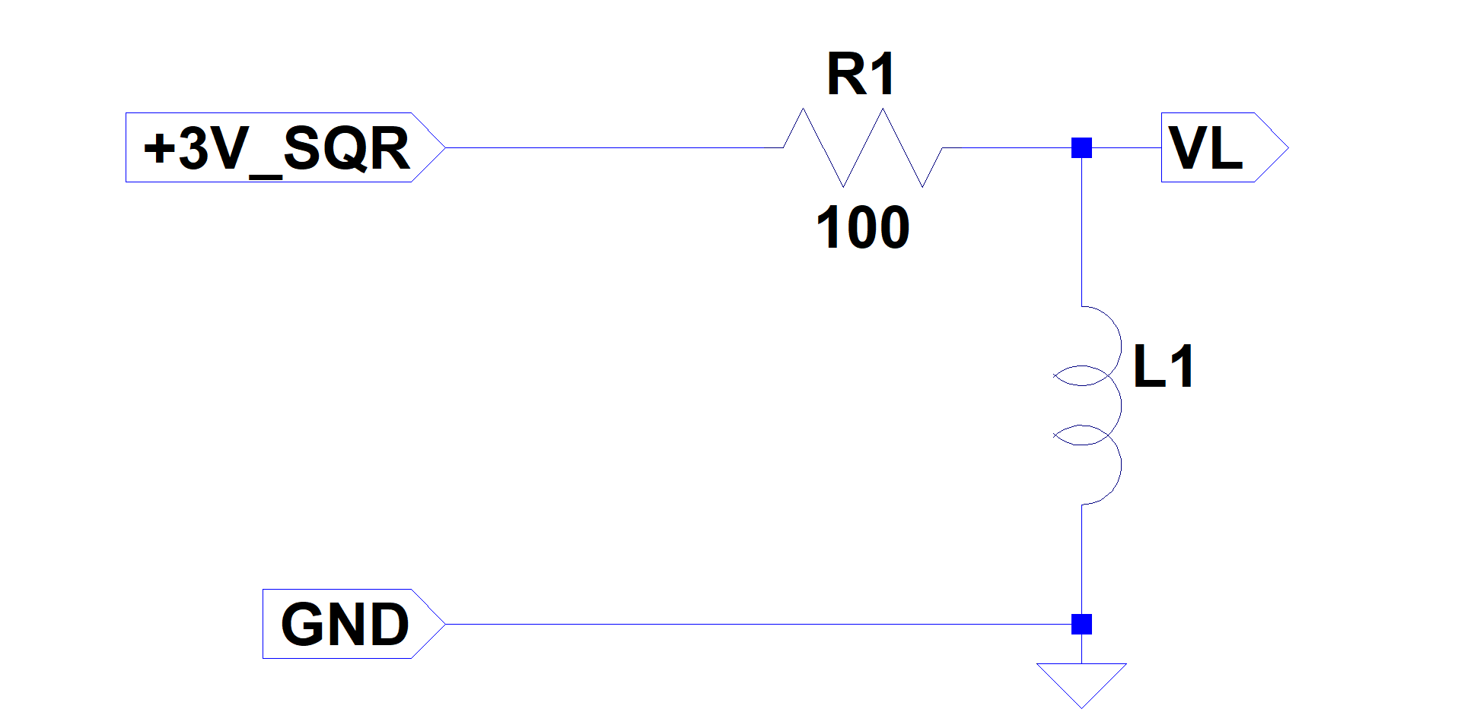
* Set your function generator to output a square wave with amplitude of 1.5V (peak to peak voltage Vpp = 3V) and offset of 1.5V.
* Connect the output of the function generator to the input of your circuit.
* Connect your scope probe to VL.
* Adjust the function generator’s frequency until you can clearly observe the charge time of the inductor on the scope.   
    
  Measure the charge time from the max voltage down to ~5% of the max voltage $$t_{3RL}=__________________s$$
* We know that the time it takes to charge an inductor to 95% of its full magnetic field is equal to $3L/R$. Determine the value of your inductor $$L=\frac{{R∙t}_{3RL}}{3}=___________________μH$$
* How does this value agree with the inductance you calculated for your inductor in Part 1?